Wheels of Satisfaction

Potential Into Reality

Brought to you by:

This activity ebook is licensed for your personal use only. It may not be re-sold or given away to other people. If you would like to share this book with others, please purchase an additional copy for each reader. If you’re reading this book and did not purchase it, or it was not purchased for your use only, then please purchase your own copy.
Thank you for respecting the hard work of the author.

Go ahead now and mark how satisfied you are with the various areas in your life on the wheel below. Remember change the segments to make them meaningful to you.
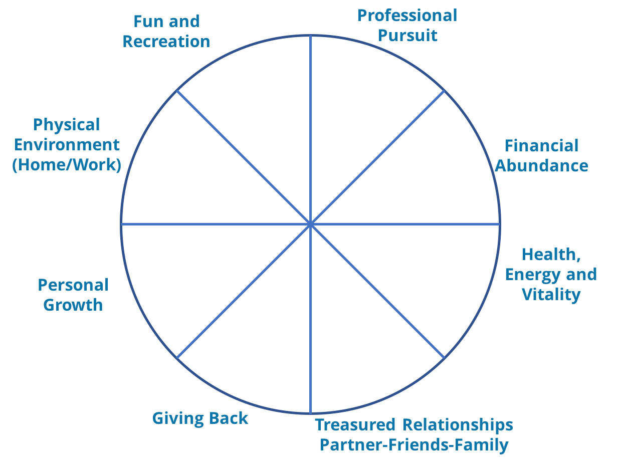
Personal Life Satisfaction Wheel
Once you've completed your current day reflections, take a different color and cast your mind back five years. Now, rate how your wheel may have looked then. What’s different? Why?
Take a third color and cast your mind forward five years. How would you like it to look? Write a couple of sentences that describe how you will be living then.

Once completed, ask yourself:
1. What if anything, do I want to change?
2. What has stopped me from giving focus to this area before?
3. How can I make changes, without putting pressure on myself?
You may also like to complete wheels for your Job Performance and your Leadership Satisfaction

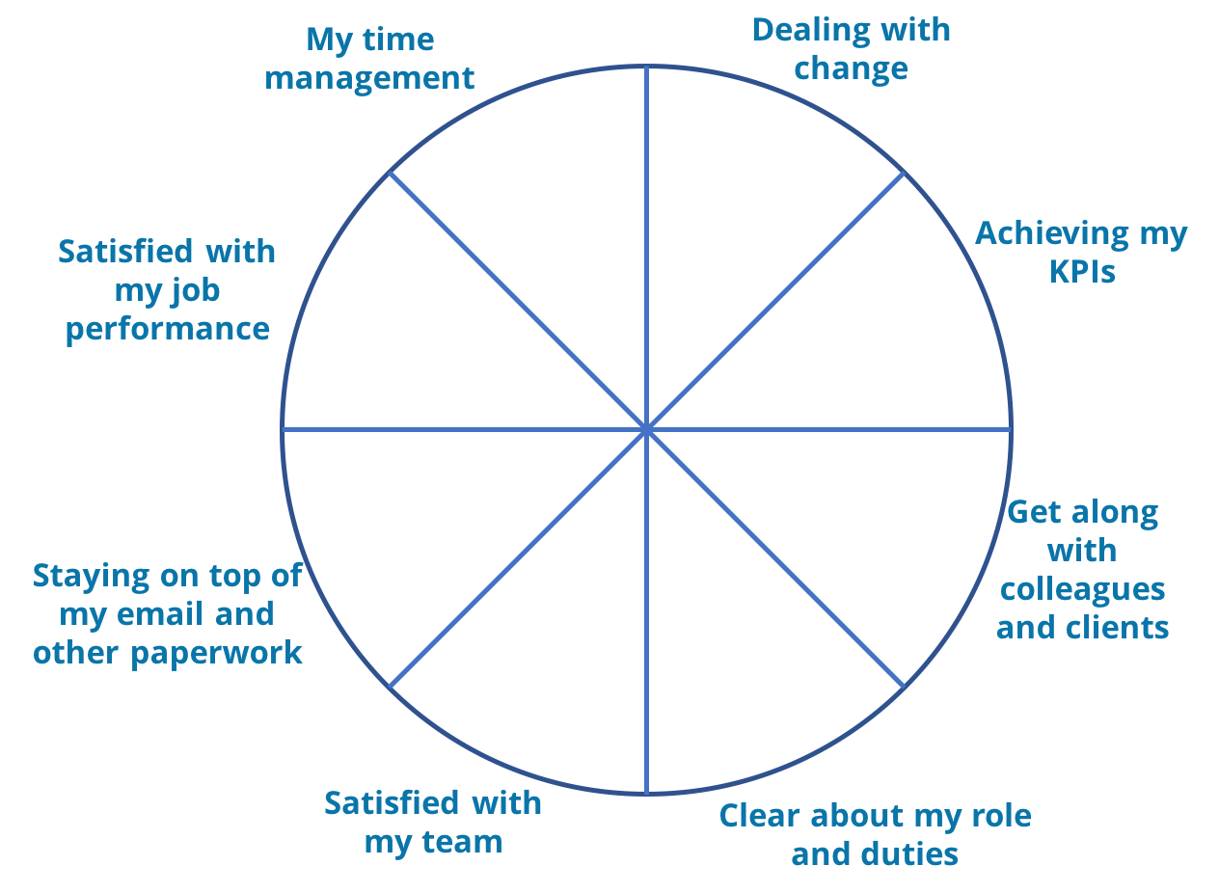
Job Performance Wheel

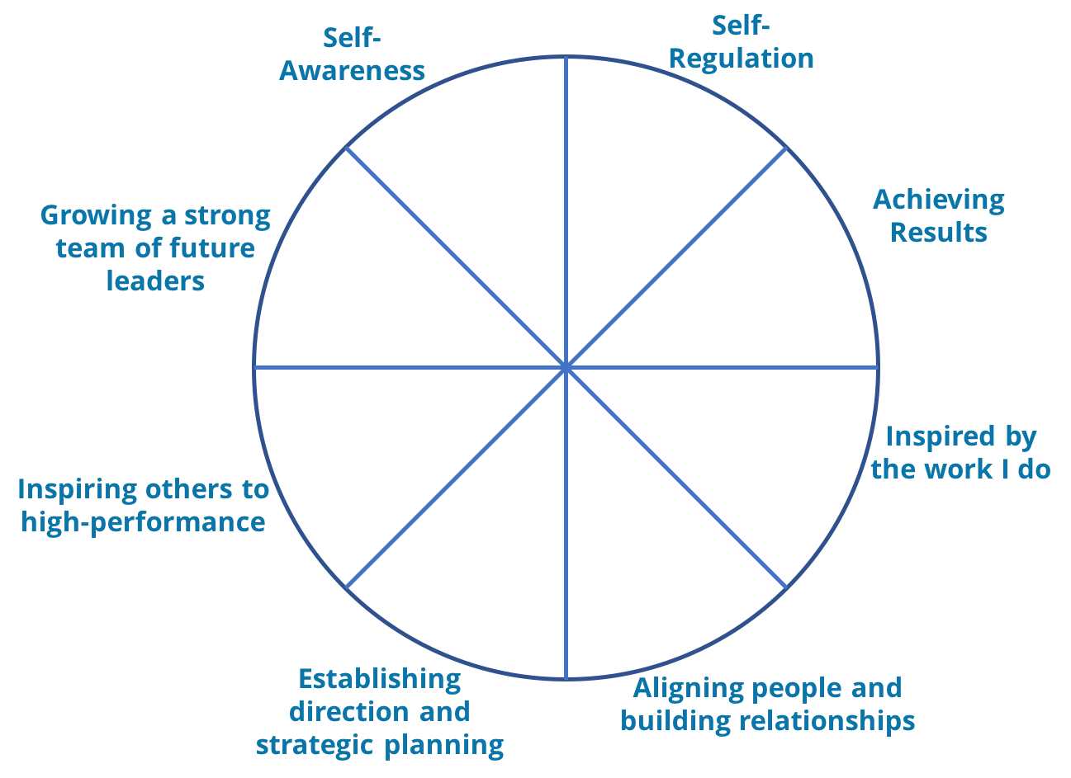
Leadership Satisfaction Wheel

